

Descriptive Statistics

Experiment-1



June 18, 2021

Bimal parajuli

20BDS0405

Descriptive Statistics

***AIM:***

Using R software, compute all descriptive statistics and interpret the result.

***R-Syntax:***

|  |  |
| --- | --- |
| R-Code | Description |
| Mean(X) | To compute the mean of X |
| Median(X) | To obtain the median of X |
| Quartile(X) | Find all the quartiles of X. |
| Range(X) | To find the range of X |
| Var(X) | To find the variance of X |
| Table(X) | To create the frequency table of X |
| X[n] | To obtain the data in nth column of data vector X. |
| Var(X, Y) | Calculate the covariance of X and Y |
| IQR(X) | Find the interquartile range of X. |
| Length(X) | Find the length of vector X. |
|  |  |

***Tools Used:***

R-Studio (IDE)

R (programming language)

Problem 1:

Twenty students, graduates and undergraduates, were enrolled in a statistics course. Their ages were 18,19,19,19,19,20,20,20,20,20,21,21,21,21,22,23,24,27,30,36.

a) Find Mean and Median of all students

b) Find median age of all students under 25 years.

c) Find modal age of all student

|  |
| --- |
| ***R- Code:*** |

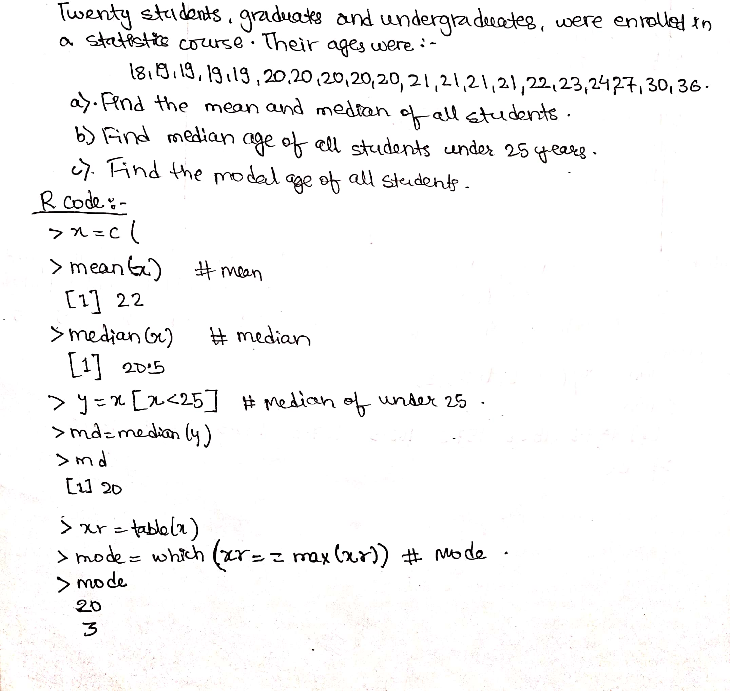

Problem 2:

A survey of 25 faculty members is taken in a college to study their vocational mobility. They were asked the question “In addition to your present position, at how many educational institutes have served on the faculty? Following is the frequency distribution of their responses.

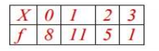

Find mean and median of the distribution

|  |
| --- |
| ***R- Code:*** |

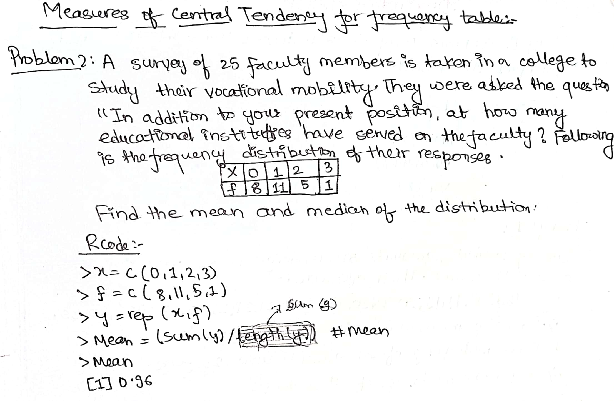

Problem 3:

Compute mean, median and mode of for the following frequency Distribution:

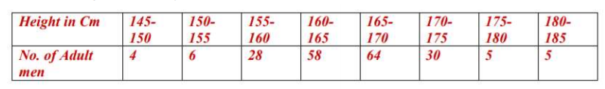

|  |
| --- |
| ***R- Code:*** |

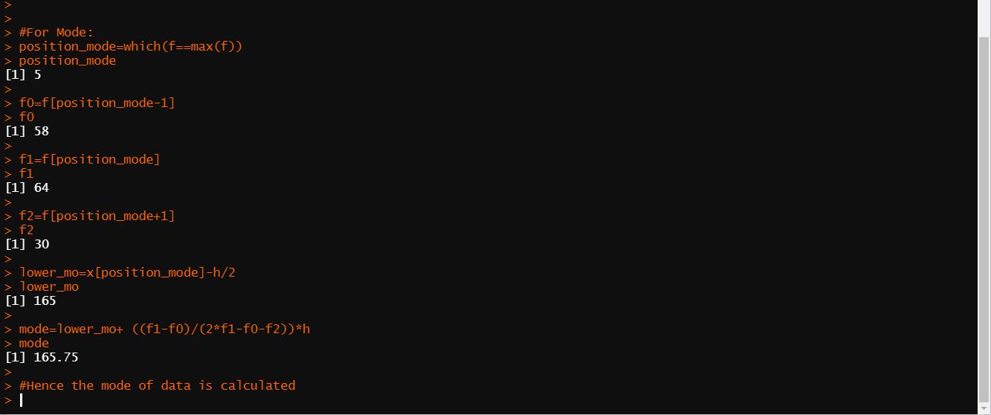

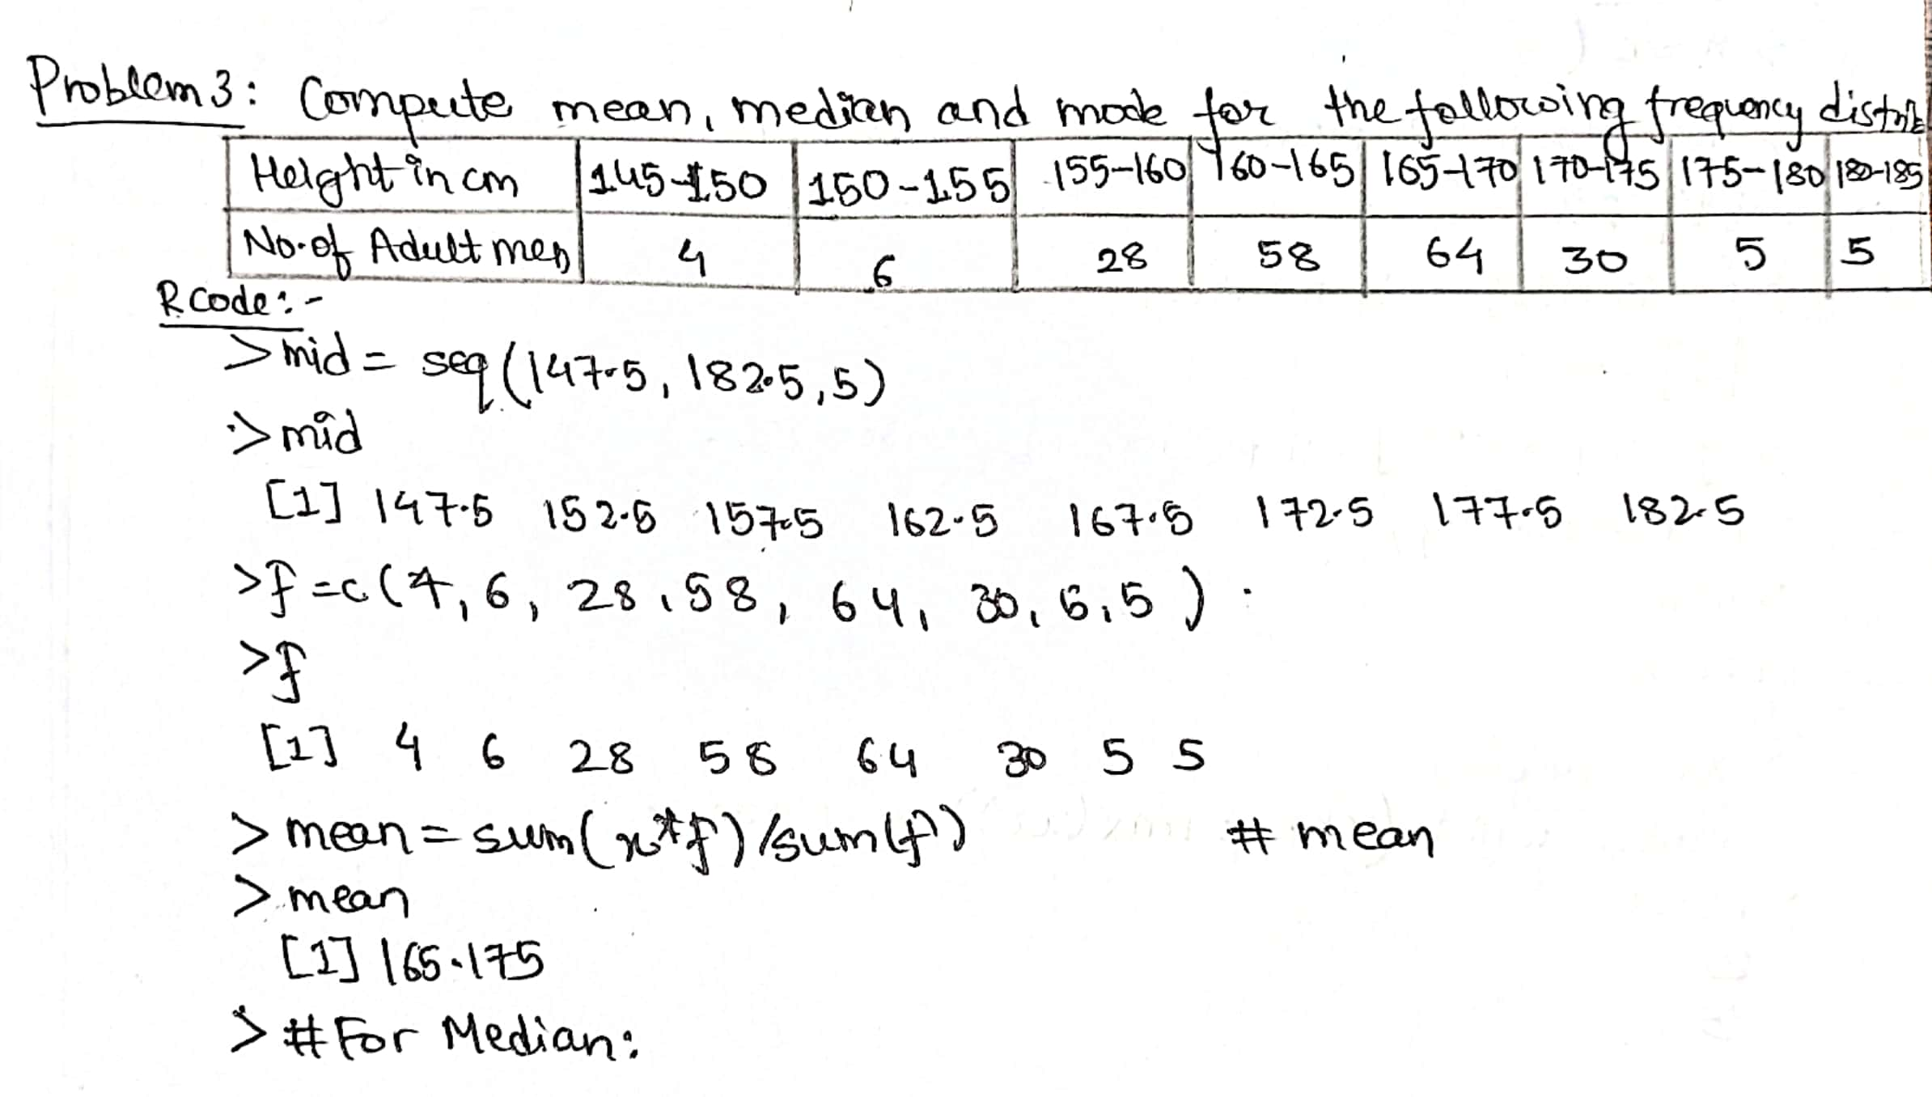

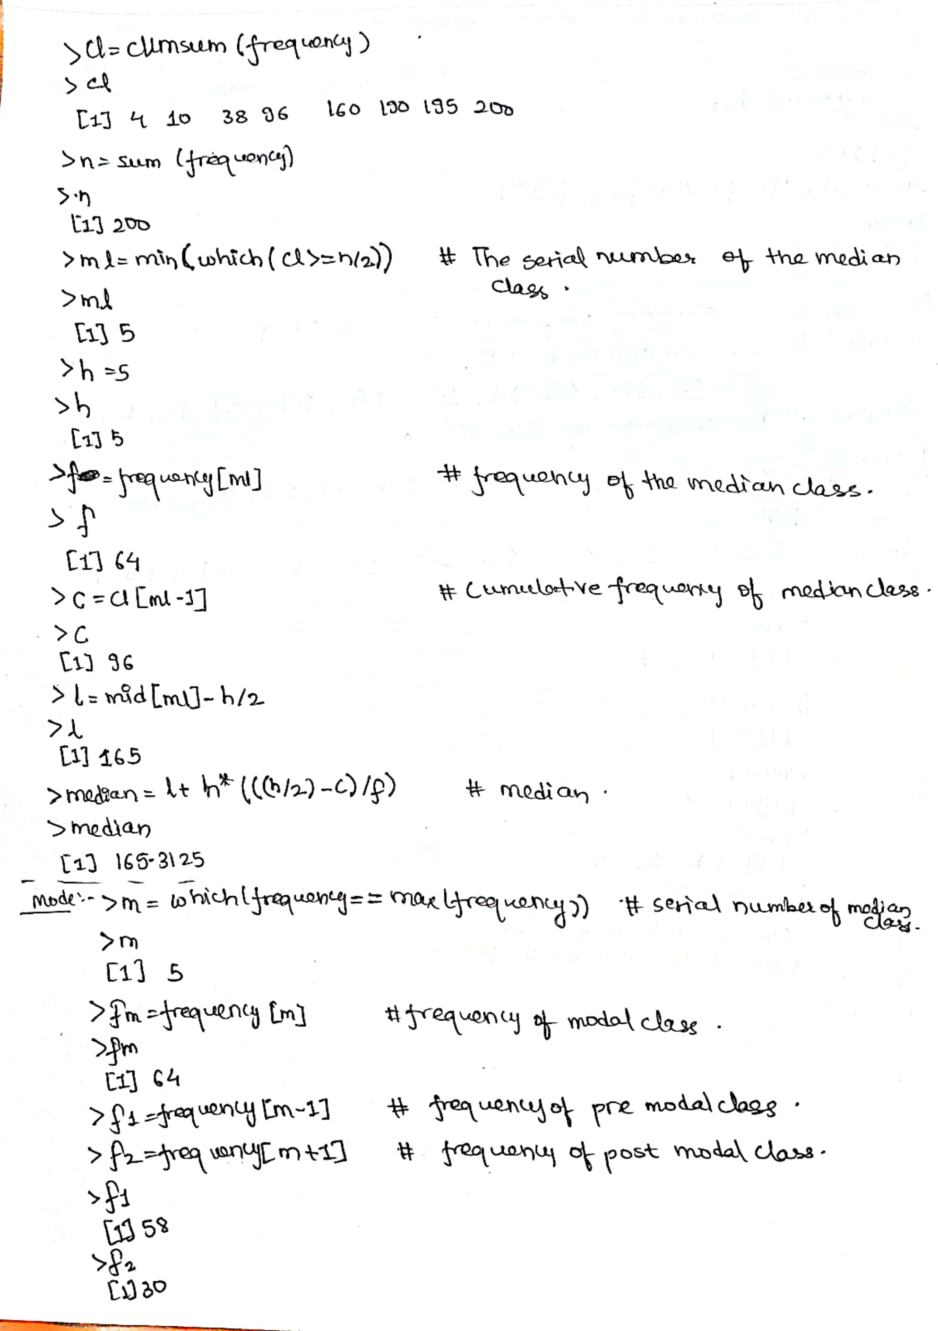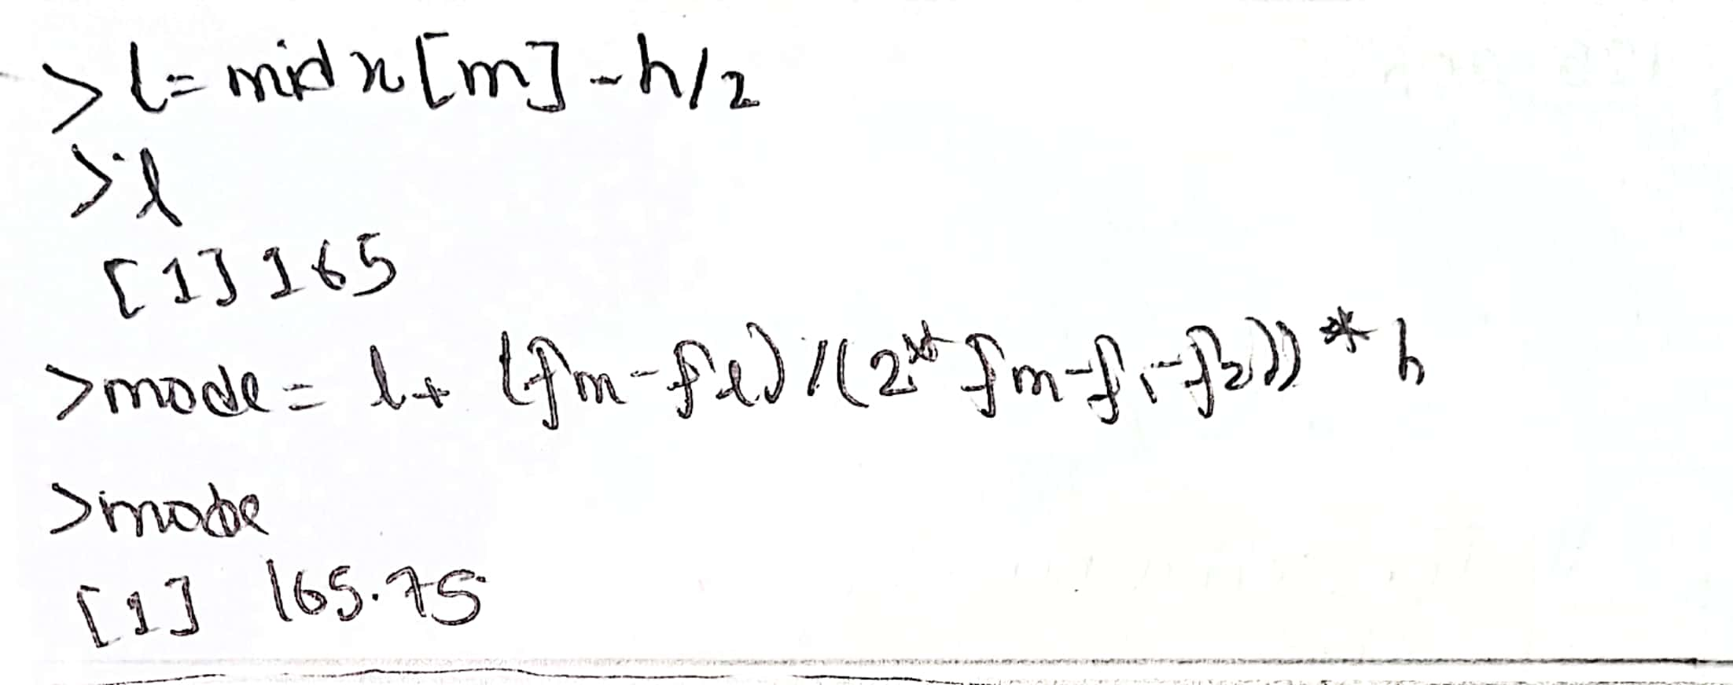

Problem 4:

*An entomologist studying morphological variation in species of mosquito recorded the following data on body length: 1.2, 1.4, 1.3, 1.6, 1.0, 1.5, 1.7, 1.1, 1.2, and 1.3.*

*Compute all the measures of dispersion.*

